An Analysis of Career Trajectories:
Salary & Experience Across Global Industries
Submitted by : GOKUL PRASANTH.P
Course : DA/DS, Offline
Batch : JUNE 2025

1. Project Objective
The objective of this project is to analyze global career trajectories by examining the relationship between salary, experience, education level, and other demographic attributes across various industries. The goal is to derive insights into how professional experience, job title, location, and gender influence earning potential and career progression globally.

2. Dataset Description
The dataset used for this project is a global salary survey containing information on professionals from different industries and roles. It includes the following attributes:
• Age Range
• Industry
• Job Title
• Clarification of Job Title
• Annual Salary
• Additional Monetary Compensation
• Currency
• Income Clarification
• Country, State, and City
• Years of Professional Experience Overall
• Years of Professional Experience in Field
• Highest Level of Education Completed
• Gender

3. Data Cleaning and Preprocessing
The dataset underwent several preprocessing steps to ensure data quality and consistency before analysis:
1. Missing values were identified and handled appropriately.
• Numerical fields such as 'Annual Salary' were imputed using the median.
• Categorical fields such as 'Industry' and 'Job Title' were filled with 'Unknown'.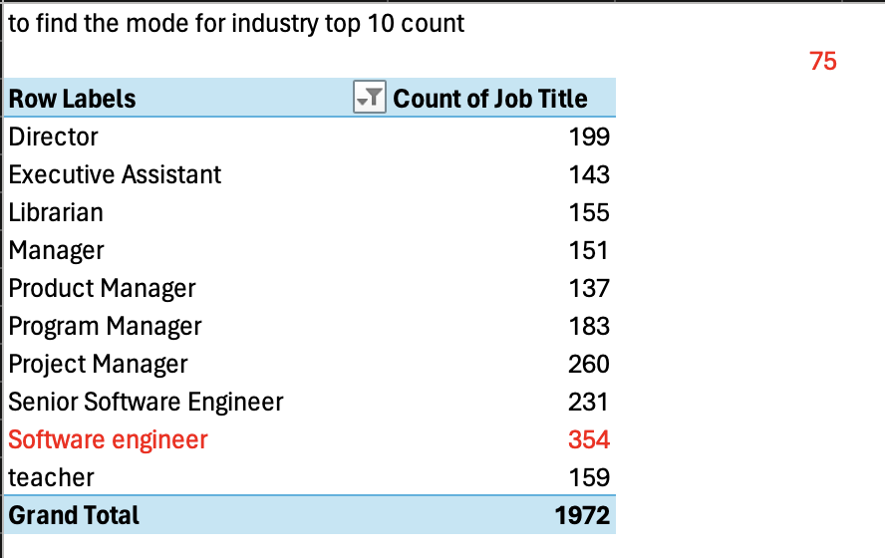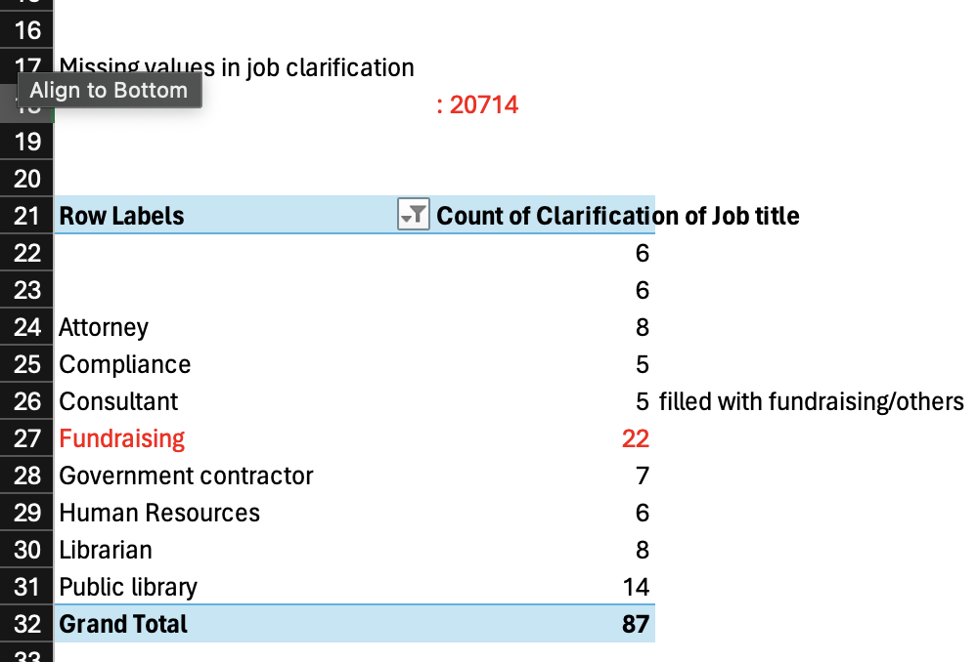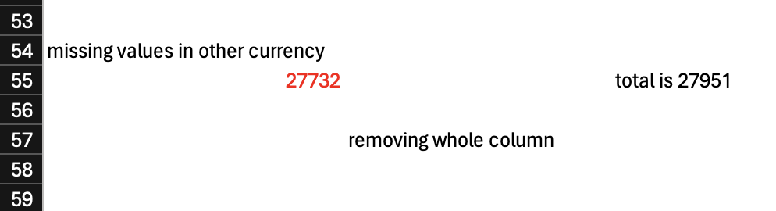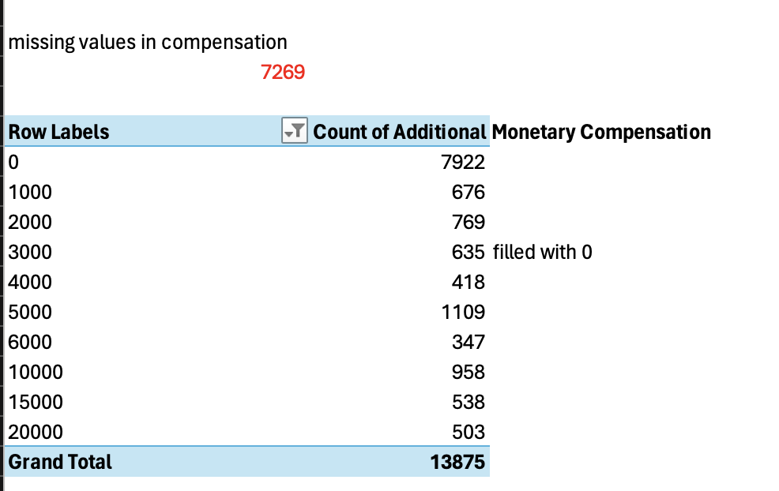
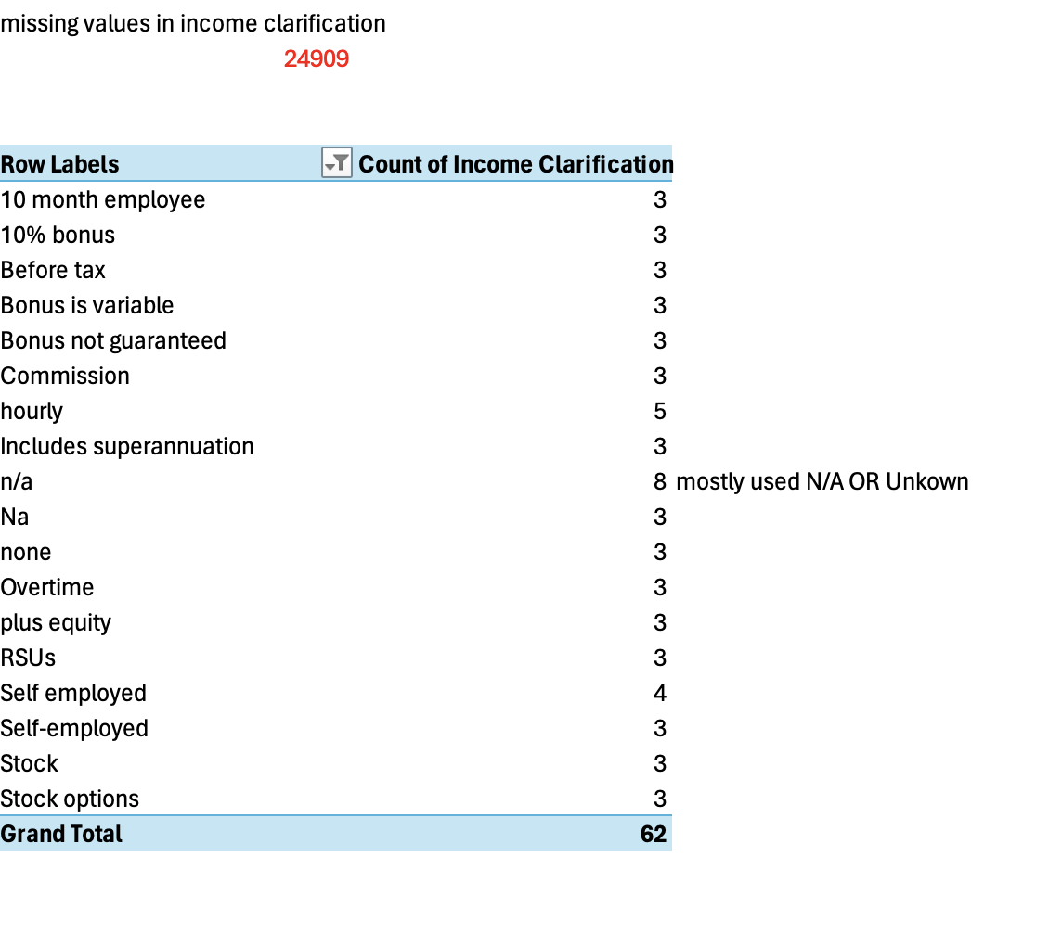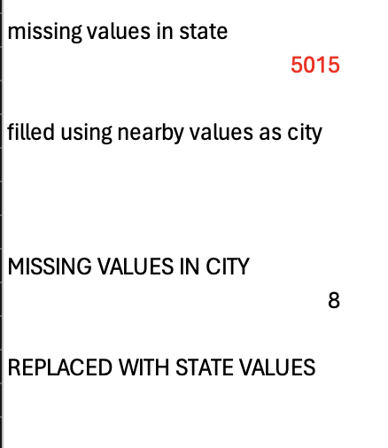
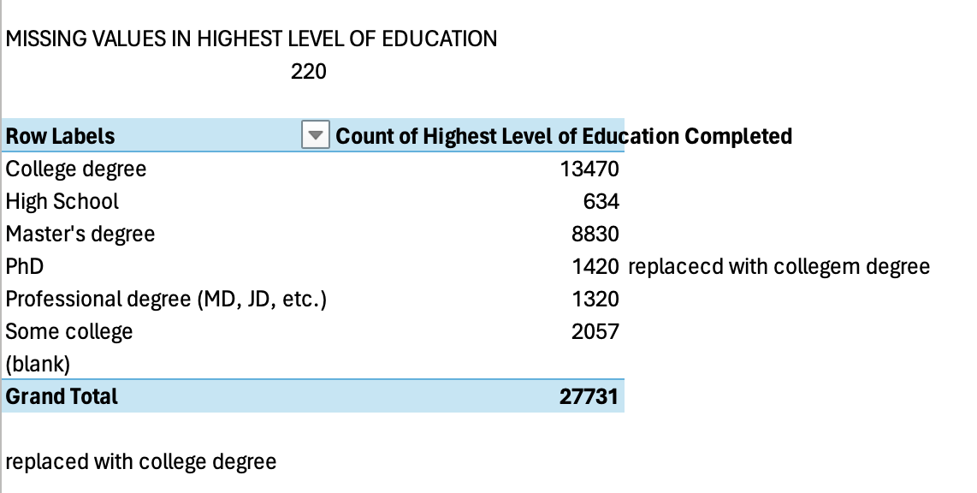
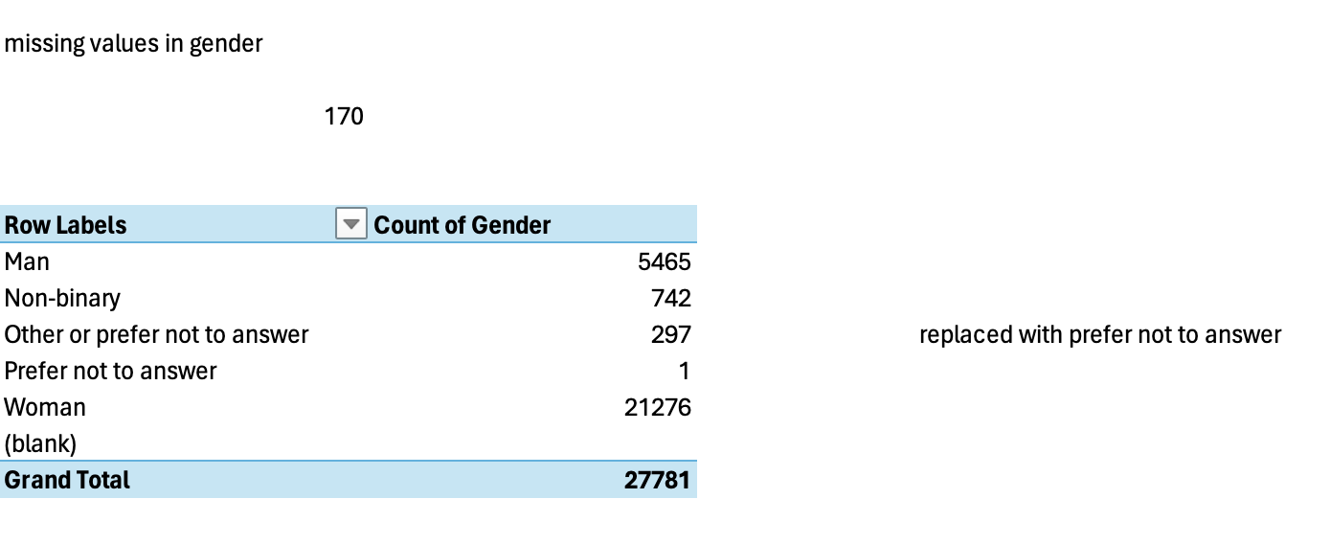
2. Data types were standardized across columns.
3. Inconsistent spellings, capitalization, and country names were corrected.
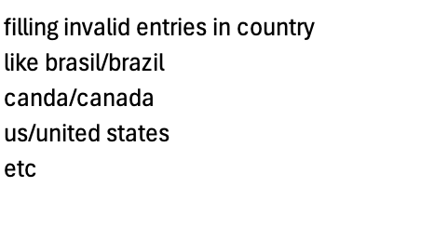
4. Outliers in salary data were detected and treated where necessary.
The cleaned dataset was saved as 'Cleaned.csv' for database import.

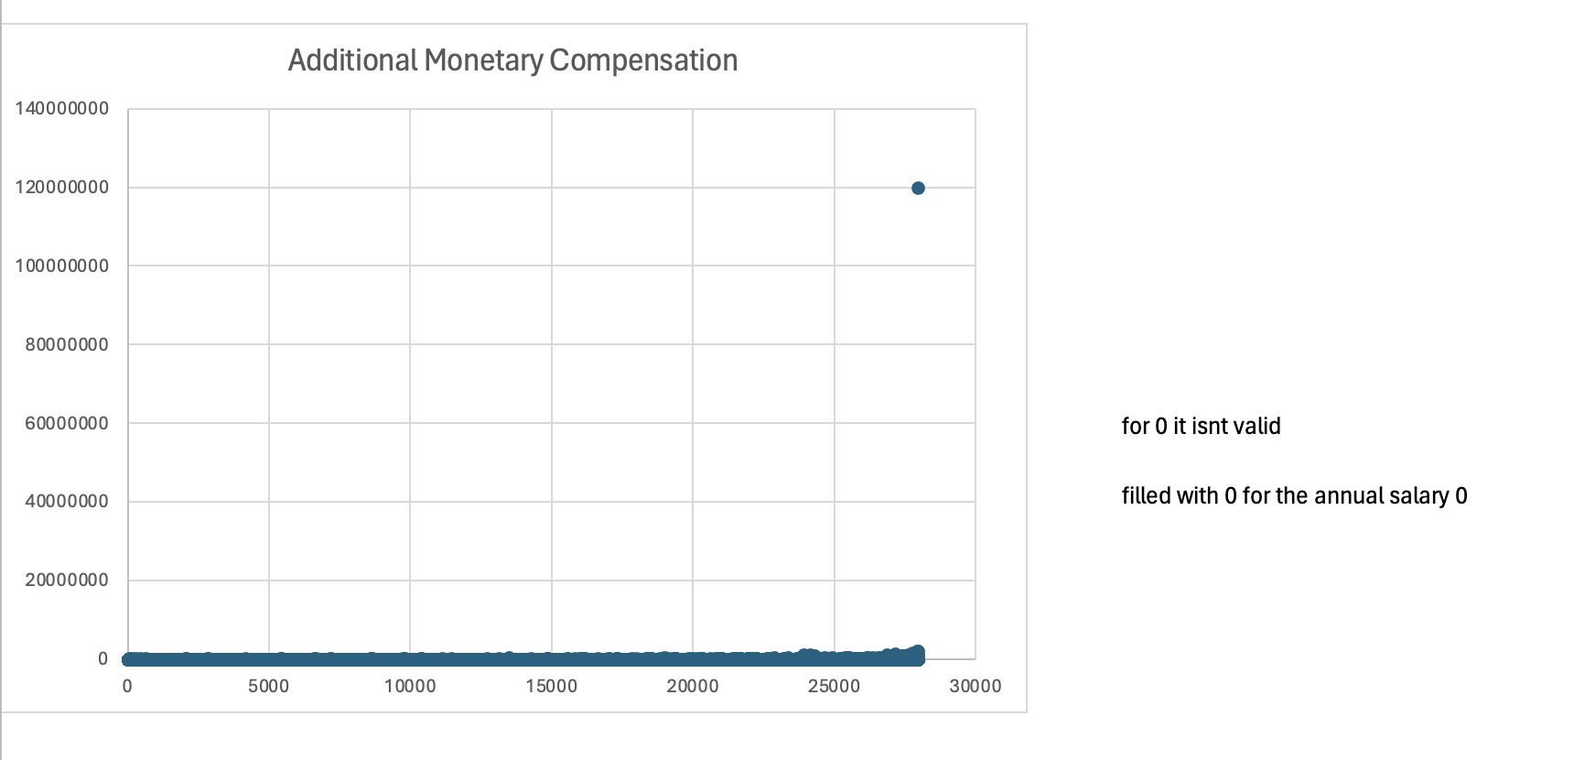

4. Database Creation and SQL Integration
A MySQL database named 'salary_analysis' was created to store :
query the cleaned dataset. A table 'salary_data' was designed with appropriate data types for each attribute. The dataset was imported using the LOAD DATA INFILE command.
5. SQL Queries and Insights
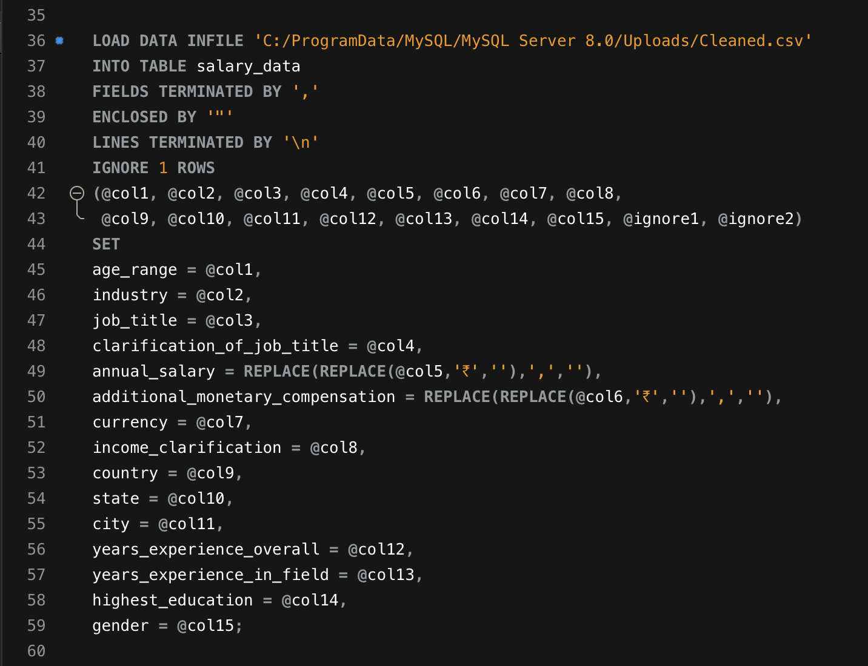

Average Salary by Industry and Gender
This query revealed noticeable salary differences across industries and genders. Industries like Technology and Finance showed higher average salaries, with some gender pay gaps visible. The SQL script included all required table creation and loading commands.

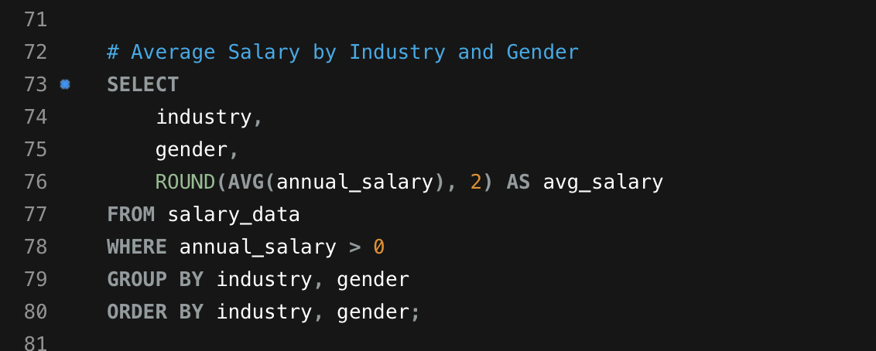

Total Salary Compensation by Job Title
The analysis showed that senior managerial roles and specialized technical positions commanded the highest total compensation.
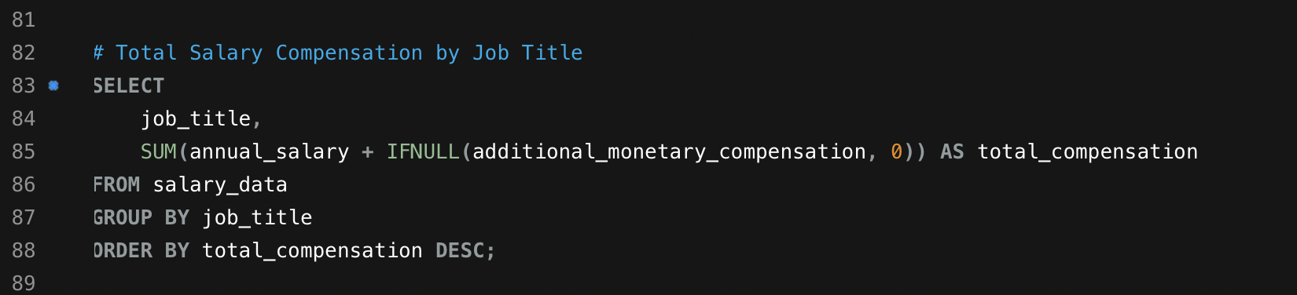

Salary Distribution by Education Level
Higher education levels correlated strongly with higher average salaries. PhD holders and Master's graduates had significantly higher earnings.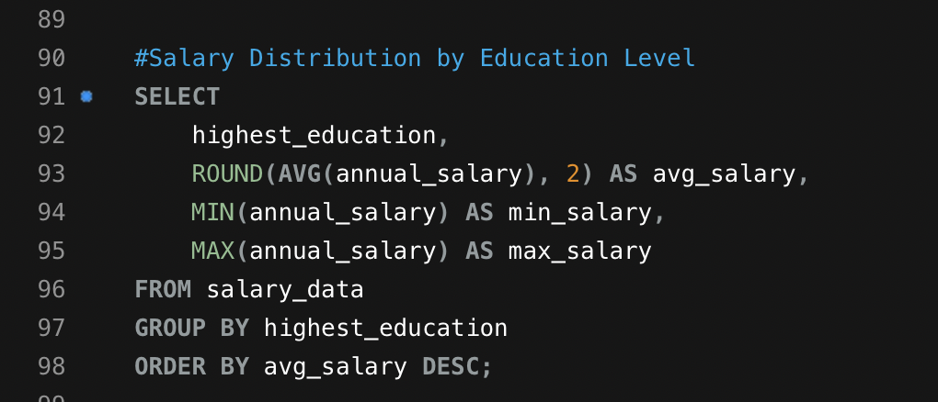

Number of Employees by Industry and Experience
Most experienced professionals were concentrated in Technology, Healthcare, and Finance sectors.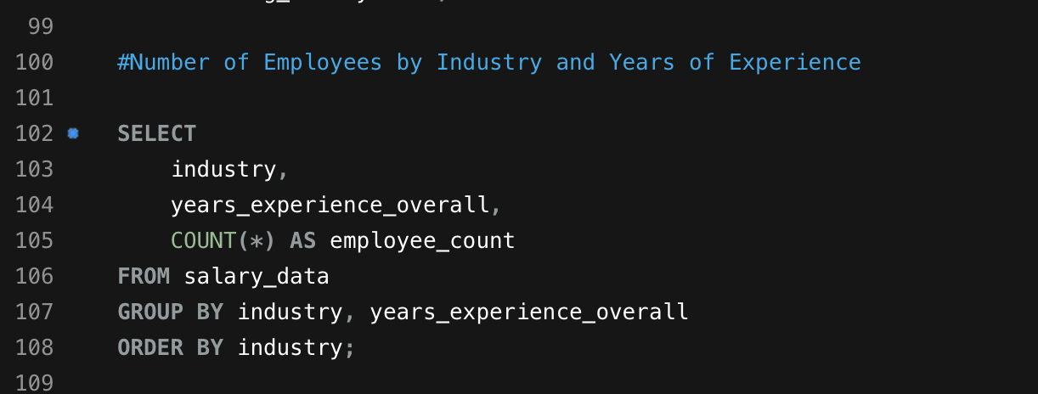

Median Salary by Age Range and Gender
Median salaries increased with age, peaking in the 35–45 range before plateauing.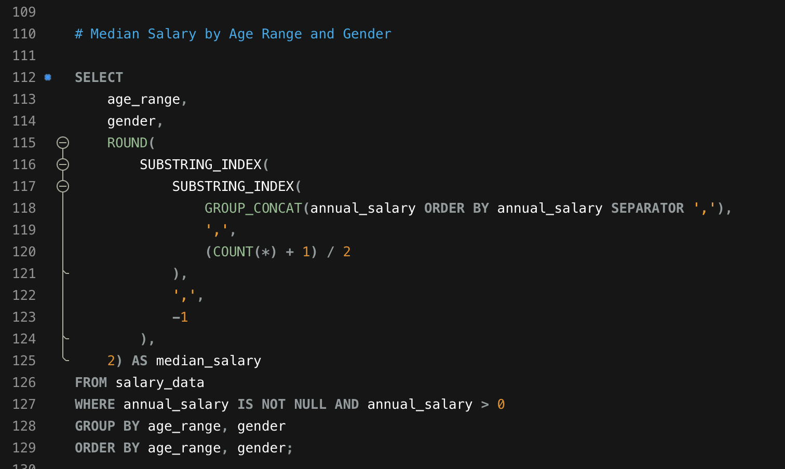

Job Titles with the Highest Salary in Each Country
Top-paying roles varied by region—Software Engineers and Data Scientists were highest in the US, while Managers led in Europe.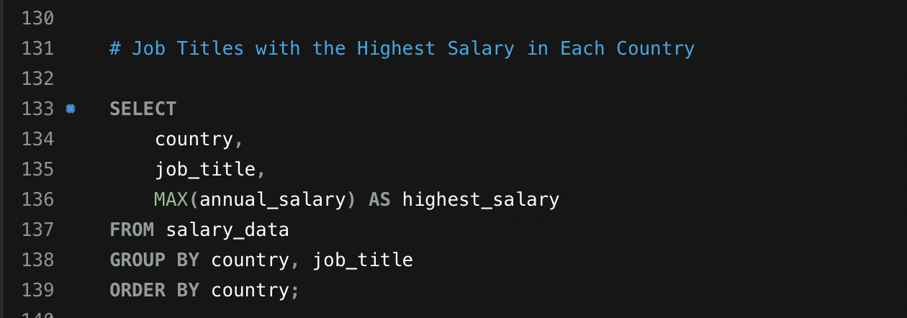

Average Salary by City and Industry
Cities like San Francisco, London, and Bangalore reported higher average salaries within the technology sector.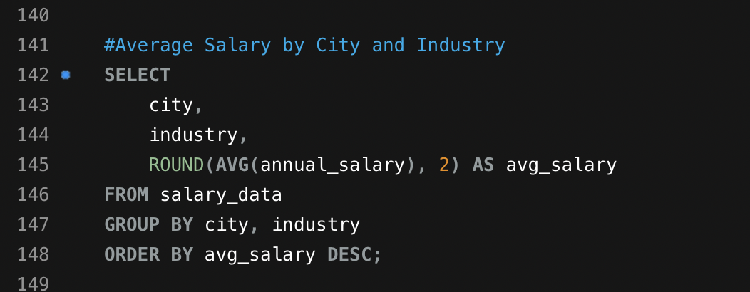

Percentage of Employees with Additional Compensation by Gender
A higher percentage of male employees received additional bonuses compared to female employees, indicating potential benefit disparities.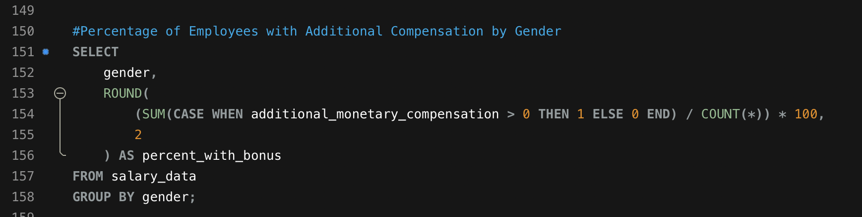

Total Compensation by Job Title and Experience
There was a strong positive relationship between years of experience and total compensation across all job roles.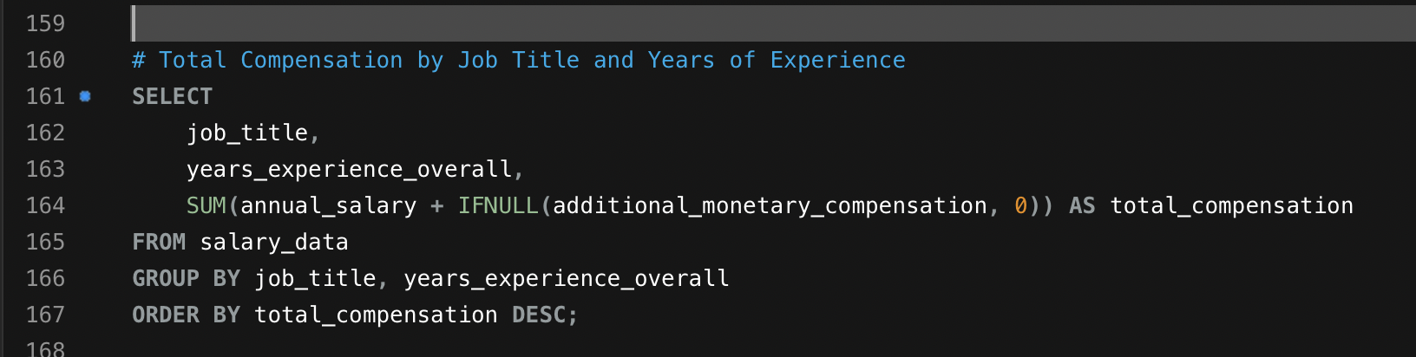

Average Salary by Industry, Gender, and Education Level
This combined query revealed that education amplified salary benefits across industries, particularly in technical and financial fields.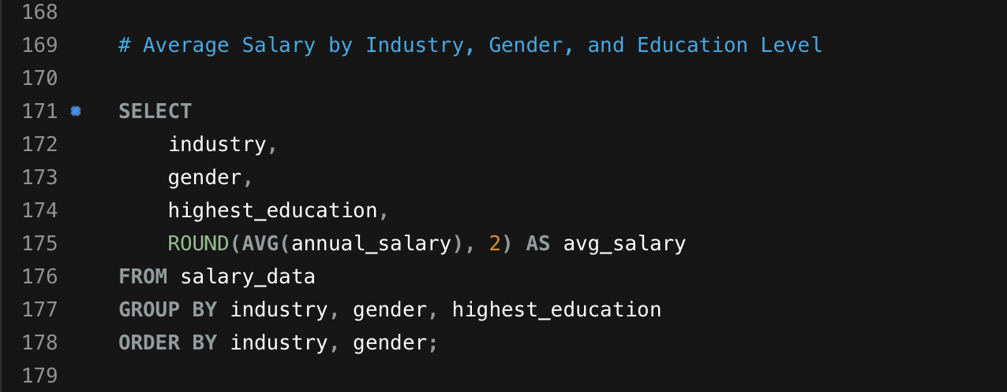

6. Excel Dashboard Creation
The SQL query results were exported from MySQL and imported into Excel. Separate sheets were created for each analysis result. Pivot tables and charts were developed to visualize patterns and trends. A final dashboard was created summarizing key findings such as salary distribution, gender representation, and top-paying industries.
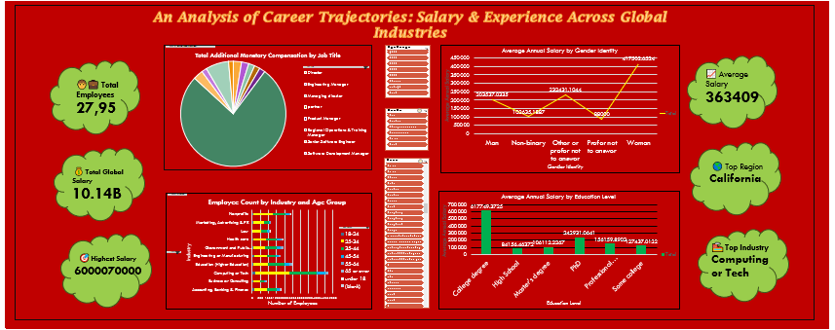

7. Key Insights and Findings
• Technology and Finance industries offered the highest salaries globally.
• Salary growth correlates strongly with professional experience and education level.
• Gender pay disparities exist across several industries, though narrowing in some regions.
• Cities like San Francisco and London remain salary hubs for technical roles.
• Senior management and specialized technical roles consistently yield the highest compensation.

8. Conclusion
This analysis provides a comprehensive understanding of how salaries vary globally across industries, education levels, and experience ranges. It highlights the importance of higher education, experience, and industry specialization in career progression. The final dashboard and SQL analyses serve as valuable tools for organizations and individuals to make informed career and compensation decisions.

9. Tools and Technologies Used
• Microsoft Excel – Data visualization and dashboard creation
• MySQL Workbench – Database management and SQL querying
• Python (optional) – Data cleaning and preprocessing
• Microsoft Word – Report documentation

